**Week 8**

Xml program – consist of a xml file showing books and its details

Screenshots:-

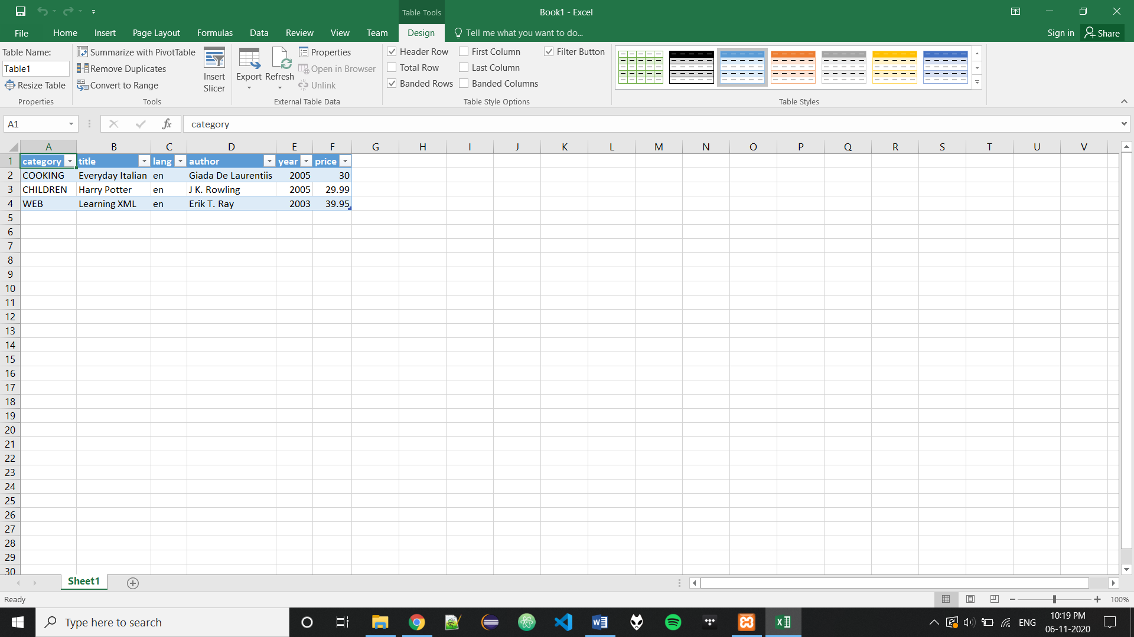

Code:-

<bookstore>

<book category="COOKING">

<title lang="en">Everyday Italian</title>

<author>Giada De Laurentiis</author>

<year>2005</year>

<price>30.00</price>

</book>

<book category="CHILDREN">

<title lang="en">Harry Potter</title>

<author>J K. Rowling</author>

<year>2005</year>

<price>29.99</price>

</book>

<book category="WEB">

<title lang="en">Learning XML</title>

<author>Erik T. Ray</author>

<year>2003</year>

<price>39.95</price>

</book>

</bookstore>